Name: Abdulrahman Ibrahim
Lab 2: Port Scanner & DNS

Lap Port Scanner Address
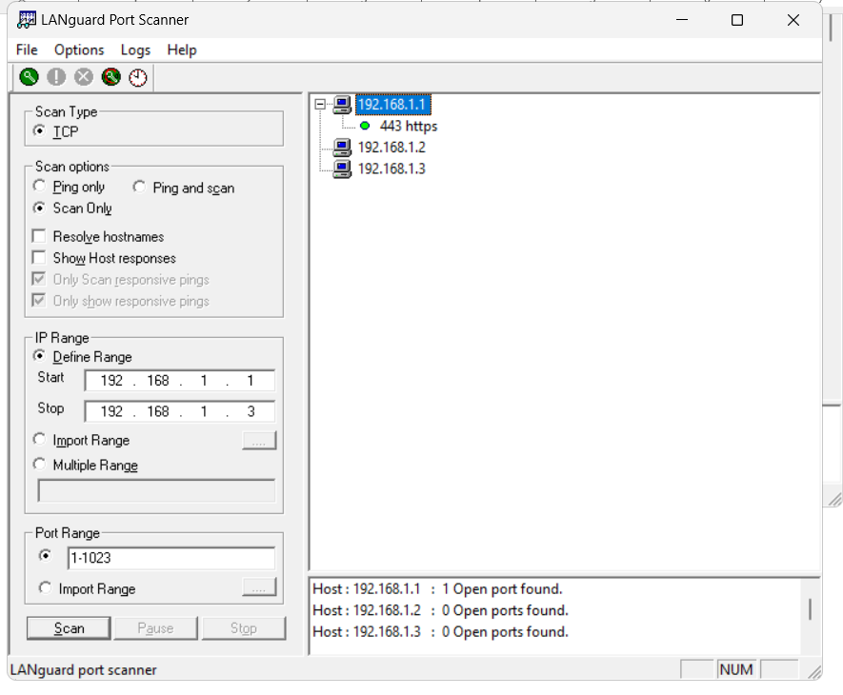

DNS
- nslookup
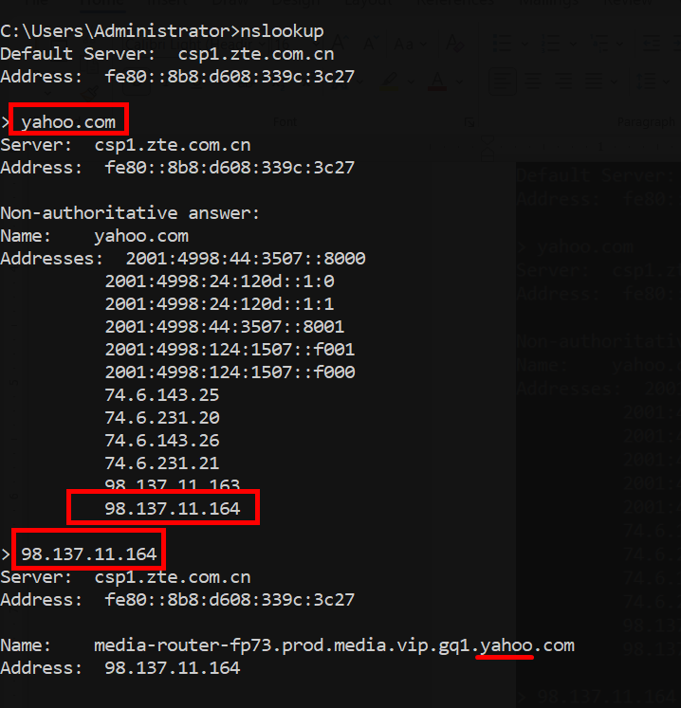

- ipconfig /displaydns
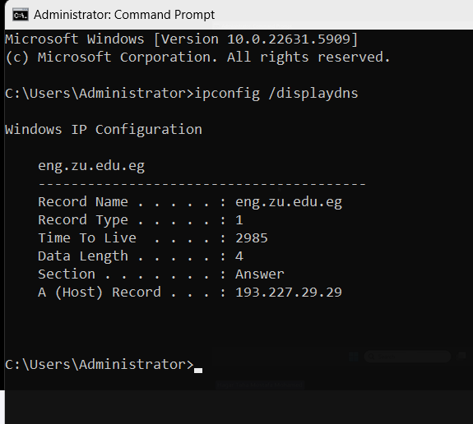

- host file
